CMOS TRANSMISSION GATE

1. OBJECTIVES
This laboratory work intends to study the static and dynamical characteristics the CMOS integrated circuits and special features in the use of CMOS circuits.

2. THEORETICAL CONSIDERATIONS
2.1 Transmission gate
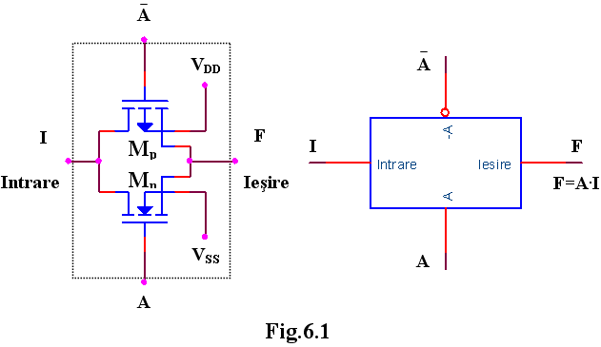
Another fundamental element in the CMOS construction is the transmission gate. It consists from a pair of complementary MOS transistor connected in parallel, like in the figure 6.1. The circuit acts like a switch, the logic variable A being the control input. When the control input A is in logic “1” and Ā in logic “0” the transmission gate is open, and between the input and output appears a small resistance which lets the current flow in any direction. The value of the input voltage must be positive related to V_{SS} and negative related to V_{DD}. When A is in logic “0” and Ā is in logic “1”, the transmission gate is blocked, and there is a big resistance between the input and the output of the circuit.
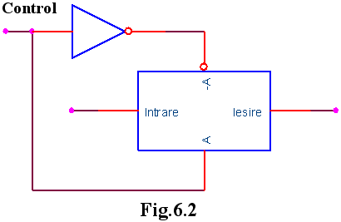
The transmission gate with an inverter forms a bilateral switch (figure 6.2).
Using transfer gates we can implement logic circuits. For example, if a=1 and b=1 the circuit from the figure 6.3 is actually an OR function. The resistance implies a power consumption in static regime if at least one gate is open.
The OR gate can be realized without resistance if there are accessible at the input the additional command signals (6.4).

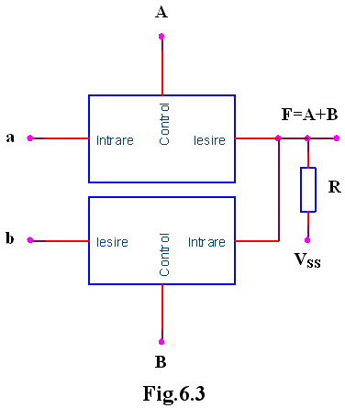
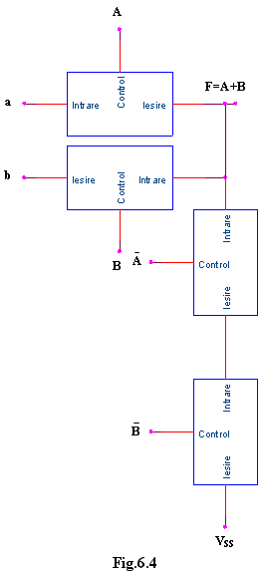
3. PRACTICAL APPROACH
- Study the behavior of the transmission gates as bilateral switches for the transmission of the digital signals.
- Realize the OR logic circuits with transmission gates and verify their OR function in static and dynamic regime.

4. THE CONTENT OF THE REPORT
  - Schemes of the circuits and their functioning.
  - Graphics obtained from the study of the static and dynamic regime of the circuits.

